1. 安裝 LINE Bot SDK

pip install line-bot-sdk==1.18.0

pip install Flask

# **開始使用 Messaging API**

https://developers.line.biz/zh-hant/docs/messaging-api/getting-started/

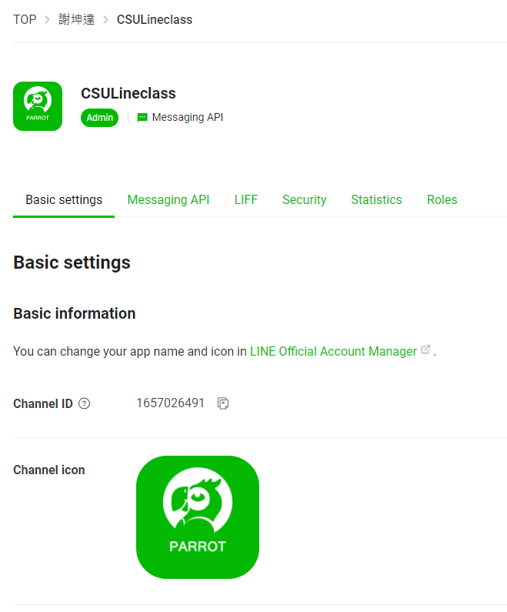

紀錄: **Channel secret**

https://github.com/line/line-bot-sdk-python/tree/master/examples/simple-server-echo